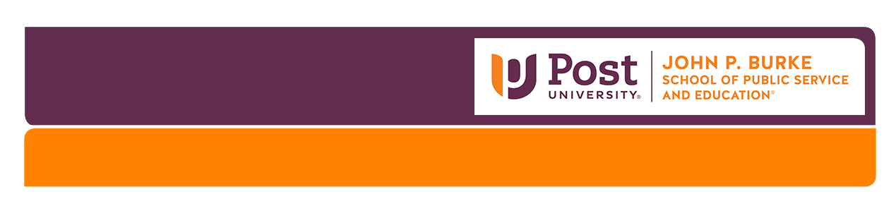

CHS 236 – Home, School & Community

Classroom Visitation Instruments: 1. Observation and 2. Documentation Review

Due: Midnight Sunday of Unit 4.

PRIOR TO YOUR CLASSROOM VISITATION
- Become familiar with both instruments.
- Reflect on the characteristics of the “Four Versions of Family-School Partnerships”.
(Henderson, A. T., Mapp, K. L., Johnson, V. R., & Davies, D. (2007). Beyond the Bake Sale: The Essential Guide to Family-School Partnerships,
pages 13 – 25).

1. ENVIRONMENTAL OBSERVATION
For approximately one (1) hour:
- Observe class activities and environmental displays. Interview staff if permitted and necessary.
- Look for evidence of family representation, family engagement, teacher-family partnership, and a caring community throughout the classroom.
- Optional: observe the overall center/school environment (e.g., administrative office, corridors)
- Using explicit details, objectively record your observations.
- Submit the completed environmental observation instrument at the end of Unit 6.

Name of Center/School: ____________________________________________________________ Date & Time: ________________________

CHS236 Student Observer: _____________________________________ Observed: # Children: _____ # Staff: _____ # Families: _____
FAMILY REPRESENTATION
Environmental Displays | Description (Provide specific details.)
- Photographs of children and their families

- Postings of family diversity (culture, race, ethnicity, ability, structure, adoption, grandparents raising grandchildren)
- Recognition of family strengths, talents, occupations
- Multilingual print depicts children’s home languages
Materials
- Books, pictures, educational toys, music and computer software represent diversity
- Authentic materials from children’s cultures/homes
Other:
FAMILY ENGAGEMENT
Curriculum Experiences
- Teachers engage children in conversations about their families
- Family input into curriculum planning (lesson plans)
- Family curriculum ideas implemented (e.g., posted and photographed stories, experience charts)
Displays (in classrooms and center entrance/corridors)
- Designated Parent/Family Bulletin Board
- Notice of family involvement/volunteer opportunities (Note the range of opportunities)
- Recognition of family contributions (donations, family literacy experiences, photographs, thank you letters)
- Minutes from Parent/Committee Meetings (decision input, advocacy)
Other:
FAMILY-TEACHER PARTNERSHIP & CARING COMMUNITY
Services and Resources *Note: Information on many of the listed items may be obtained through your documentation review.
- Transition support for children and families (e.g., infant, toddler, preschool entry; kindergarten transition)
- Special education support for children and families (Individual Family Service Plans; Individualized Education Plans)
- Home visits (educational and/or social services support)
- Comfortable, private space for breastfeeding mothers
- Community Resource Book readily accessible in classroom
- Promotion/awareness of community events (e.g., posted notices, personal invitations to community resource fair)
- Joint teacher-family education workshops
- Addressing differences (collaborative training such as cultural competency for staff and families)
- Family-School-Community meetings/events (publicized notices, photograph documentation on display)
- Advocacy support (family and community issues and needs)
- Sharing power (families as decision makers, school resources such as copiers and computers available for families’ use)
- Family resource room
Other:

2. DOCUMENTATION REVIEW
Review a minimum of five documents for all categories listed below.
- For approximately 45 minutes to 1 hour:
  - Review the same center/school’s documents (“Guidance for Program Documents by Category” is provided below and in the assignment instructions).
  - If the center/school provides copies that you can keep, the review can occur on- and/or off-site.
- Objectively record evidence of written procedures and strategies for engaging families.
- Using objective and explicit details, complete the review instrument.
- Submit the completed instrument at the close of Unit 6.

Name of Center/School: ________________________________________________________ Date & Time: _________________________
CHS 236 Student Observer: _____________________________________________
Category | Type and Description of Document (Provide an explicit description.)
1. Intake & Enrollment

2. Communication

3. Curriculum

4. Assessment of Child Progress

5. Family-Teacher Conferences
Optional: Additional Category

________________________________

Guidance for Program Documents by Category
1. Intake and Enrollment: methods and forms (e.g., families’ goals, hopes and dreams for their child -- “Who is This Child?”)

2. Communication: range of methods and tools
- family/parent handbook
- written program mission philosophy, policies and practices (e.g., Code of Ethics; policies on safety, nutrition, naptime, guidance and discipline)
- face to face, scheduled meetings; informal, impromptu conversations
- verbal: face to face, scheduled meetings; informal, impromptu conversations; translation support for limited and non-English speaking families
- written notices: sent home, email
- daily records (e.g., infants and toddlers’ experiences), school-home journals
- newsletters and announcements (flyers and postings)
- community resources book
- meeting notifications and/or minutes (e.g., Open House, Parent Committees, joint curriculum planning by families and teachers, participation records)

3. Curriculum: curriculum philosophies, plans and practice
    - specific curriculum (e.g., Creative Curriculum, High Scope, CT Preschool Curriculum Framework)
    - lesson plans
    - written class experiences
    - family input (e.g., curriculum committee meetings, section on lesson plans)

4. Assessment: plan, practices and tools
    - assessment approach/framework/instrument (e.g., CT Preschool Assessment Framework, Work Sampling)
    - assessment documentation (e.g., observation forms, work samples, child profile of developmental benchmarks)
    - family input (e.g., form for sharing at-home child observations)

5. Family-Teacher Conferences: schedule, process and forms, child documentation, family
    - number per year; conference notification
    - pre-conference preparation by families (e.g., sharing home observations)
    - use of a formal child progress profile indicating strengths, interests, abilities, benchmarks, areas for growth
    - family input (e.g., individual development plan)
    - agreed and signed plan by family and teacher: consistent goals and complementary action steps for home and school implementation
    - educational and/or family support home visits

